PGEB (East Bay, Climate Zone 3)

0.0 – 0.1 (Lowest Decile)

Annual energy use from cooling: 9.409369 kWh

Annual energy use from pool pump: 238.366170 kWh

Annual energy use from base load: 908.518850 kWh

Annual energy use from space heating: 946.467761 kWh

Annual energy use from water heating: 1117.539832 kWh

Annual energy use from all sources: 3220.301982 kWh

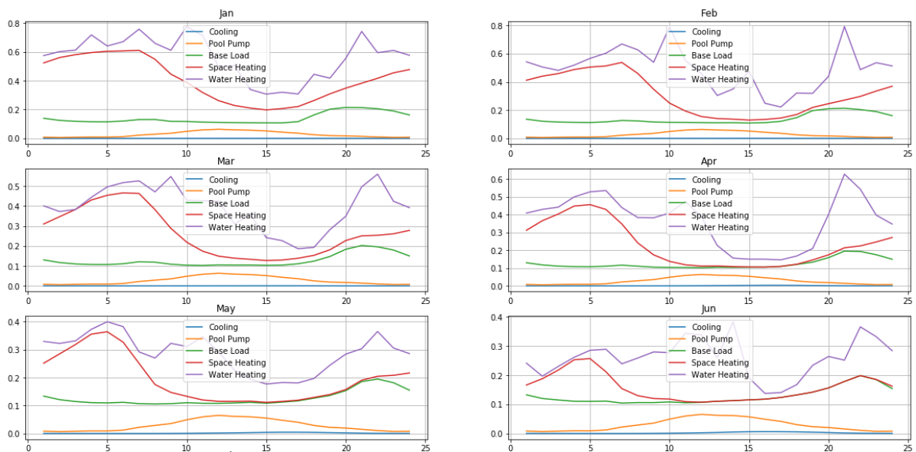

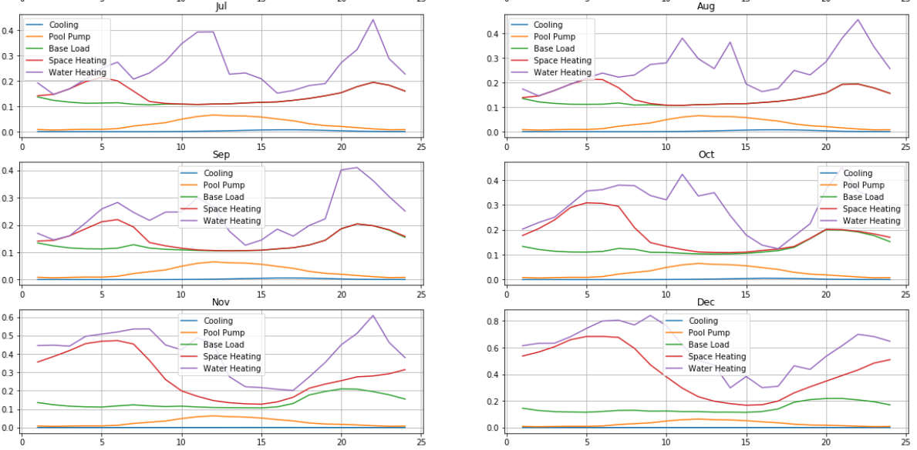

Yearly energy costs under flat rate plan: $611.857377

Yearly energy costs under tiered rate plan: $720.574771

Yearly energy costs under time of use rate plan: $555.518481

$/kWh under the cheapest plan: $0.172505

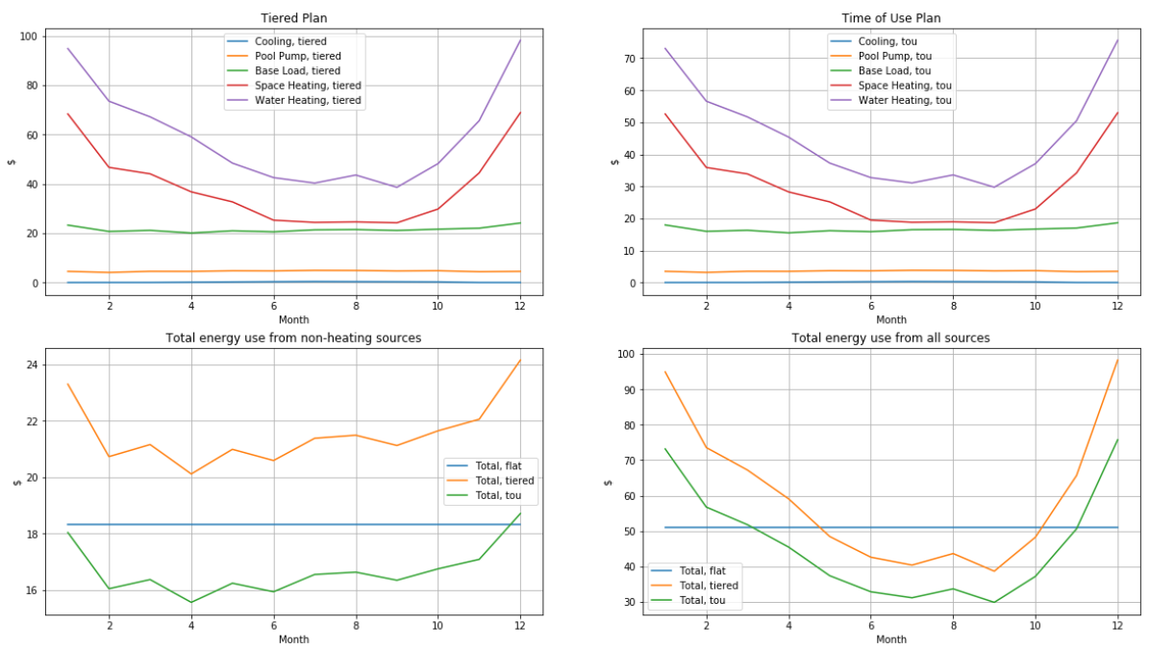

0.5-0.6 (Middle Decile)

Annual energy use from cooling: 281.718582 kWh

Annual energy use from pool pump: 238.366170 kWh

Annual energy use from base load: 4964.600192 kWh

Annual energy use from space heating: 946.467761 kWh

Annual energy use from water heating: 1117.539832 kWh

Annual energy use from all sources: 7548.692537 kWh

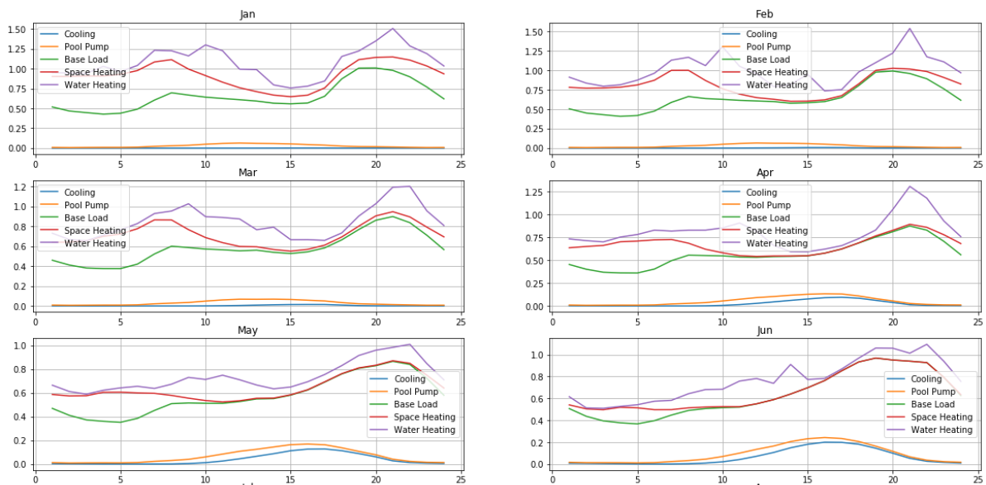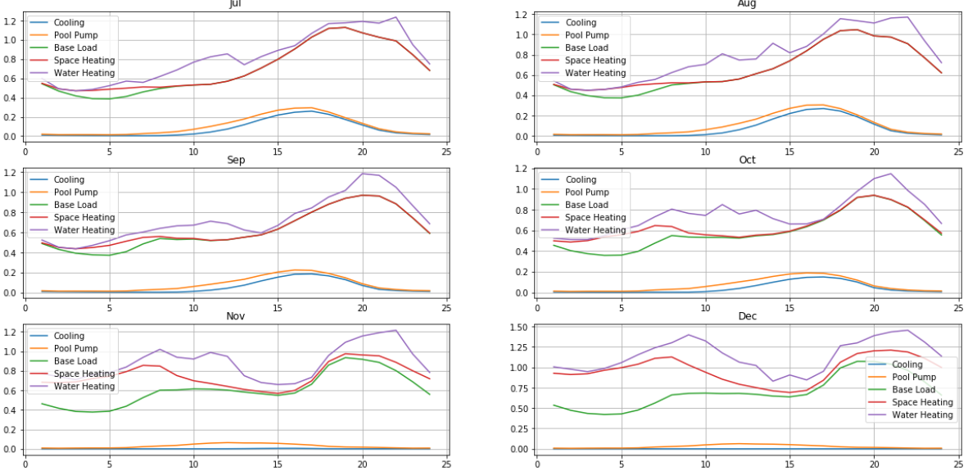

Yearly energy costs under flat rate plan: $1434.251582

Yearly energy costs under tiered rate plan: $1813.354331

Yearly energy costs under time of use rate plan: $1307.488914

$/kWh under the cheapest plan: $0.173207

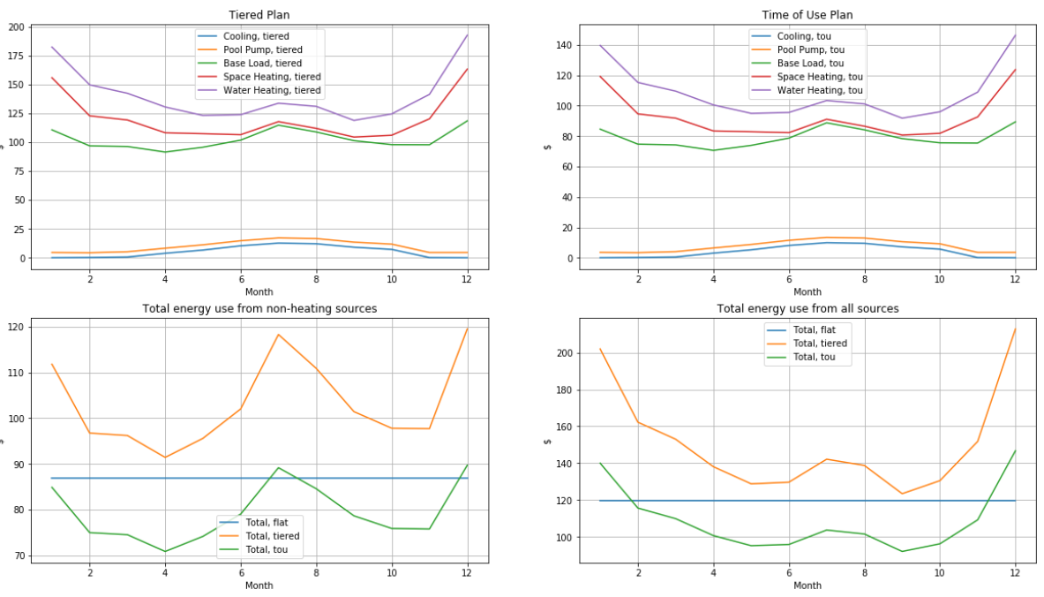

0.9 – 1.0 (Highest Decile)

Annual energy use from cooling: 1924.354451 kWh

Annual energy use from pool pump: 238.366170 kWh

Annual energy use from base load: 13963.798581 kWh

Annual energy use from space heating: 946.467761 kWh

Annual energy use from water heating: 1117.539832 kWh

Annual energy use from all sources: 18190.526795 kWh

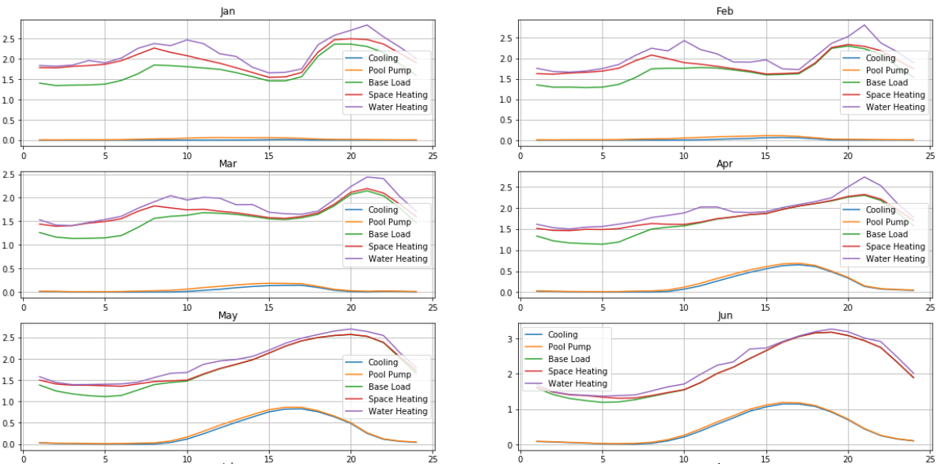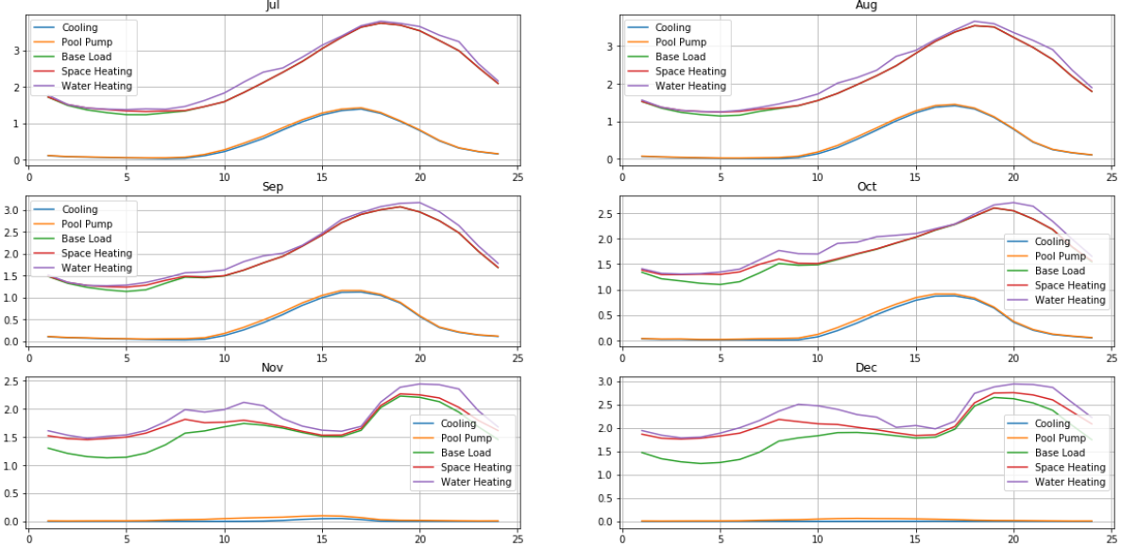

Yearly energy costs under flat rate plan: $3456.200091

Yearly energy costs under tiered rate plan: $4809.988440

Yearly energy costs under time of use rate plan: $3156.715520

$/kWh under the cheapest plan: $0.173536

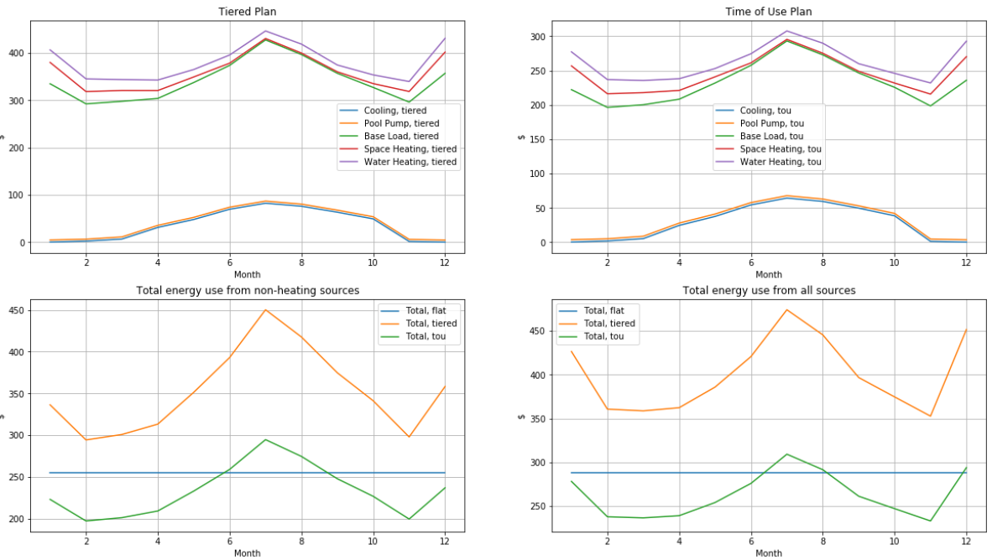

PGFG (Geysers, Climate Zone 2)

Lowest Decile

Annual energy use from cooling: 10.365109 kWh

Annual energy use from pool pump: 238.366170 kWh

Annual energy use from base load: 869.454731 kWh

Annual energy use from space heating: 1558.695002 kWh

Annual energy use from water heating: 1142.435532 kWh

Annual energy use from all sources: 3819.316544 kWh

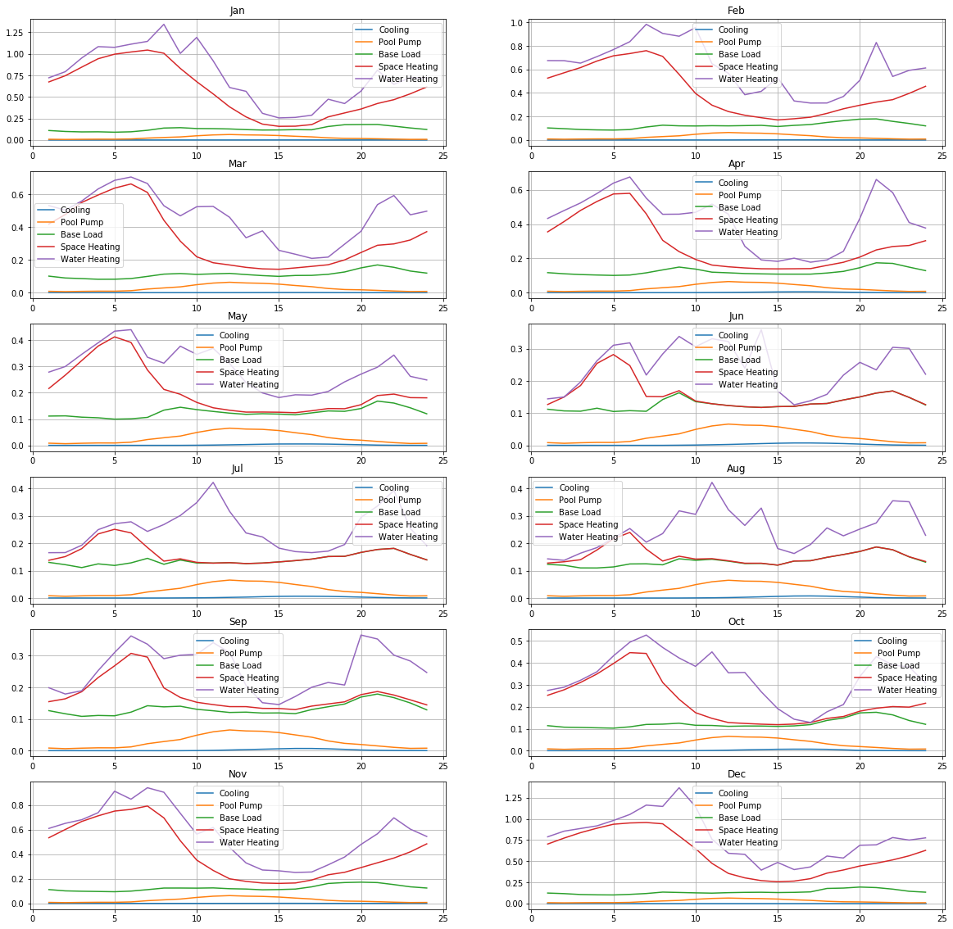

Yearly energy costs under flat rate plan: $725.670143

Yearly energy costs under tiered rate plan: $868.679232

Yearly energy costs under time of use rate plan: $658.451611

$/kWh under the cheapest plan: $0.172400

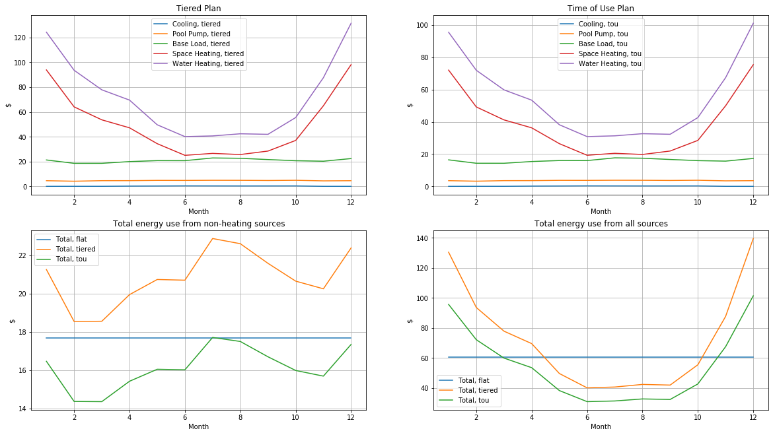

Middle Decile

Annual energy use from cooling: 218.072277 kWh

Annual energy use from pool pump: 238.366170 kWh

Annual energy use from base load: 5360.005369 kWh

Annual energy use from space heating: 1558.695002 kWh

Annual energy use from water heating: 1142.435532 kWh

Annual energy use from all sources: 8517.574350 kWh

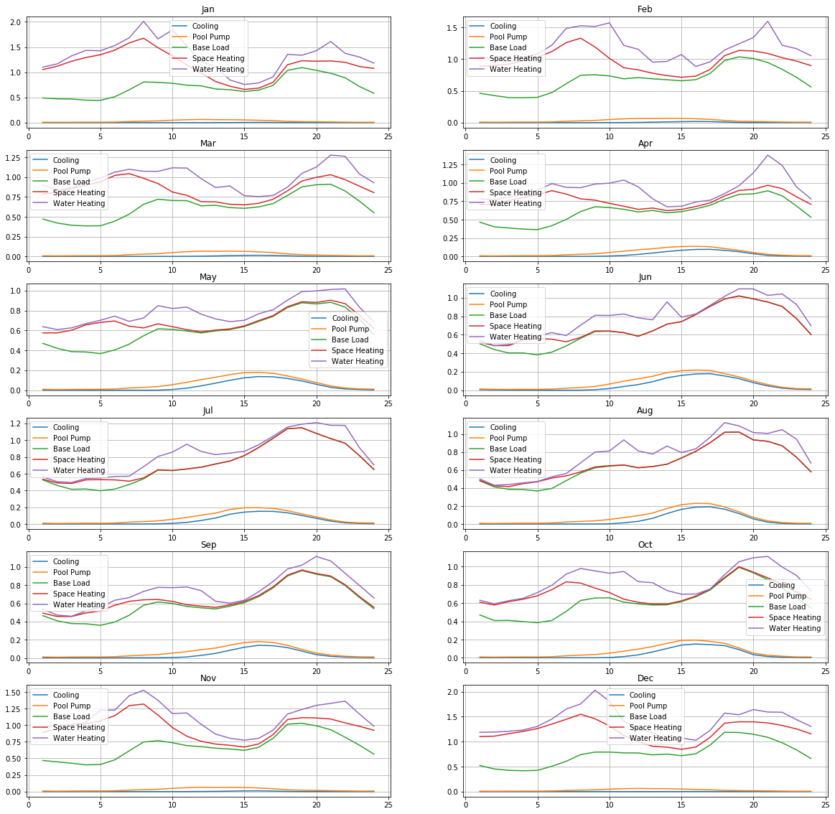Yearly energy costs under flat rate plan: $1618.339126

Yearly energy costs under tiered rate plan: $2086.181761

Yearly energy costs under time of use rate plan: $1474.765408

$/kWh under the cheapest plan: $0.173144

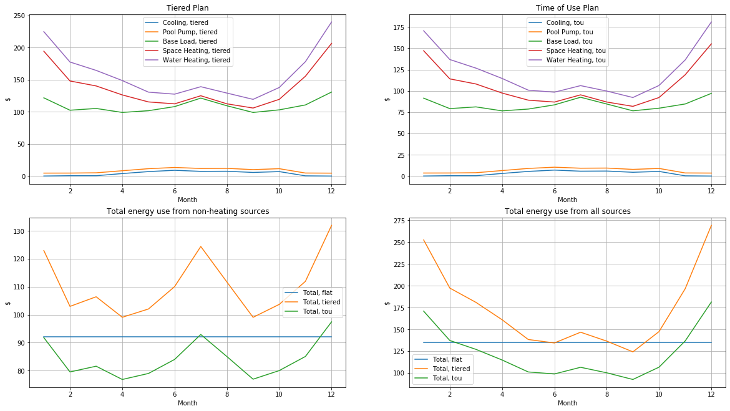

Highest Decile

Annual energy use from cooling: 848.597028 kWh

Annual energy use from pool pump: 238.366170 kWh

Annual energy use from base load: 20395.195783 kWh

Annual energy use from space heating: 1558.695002 kWh

Annual energy use from water heating: 1142.435532 kWh

Annual energy use from all sources: 24183.289515 kWh

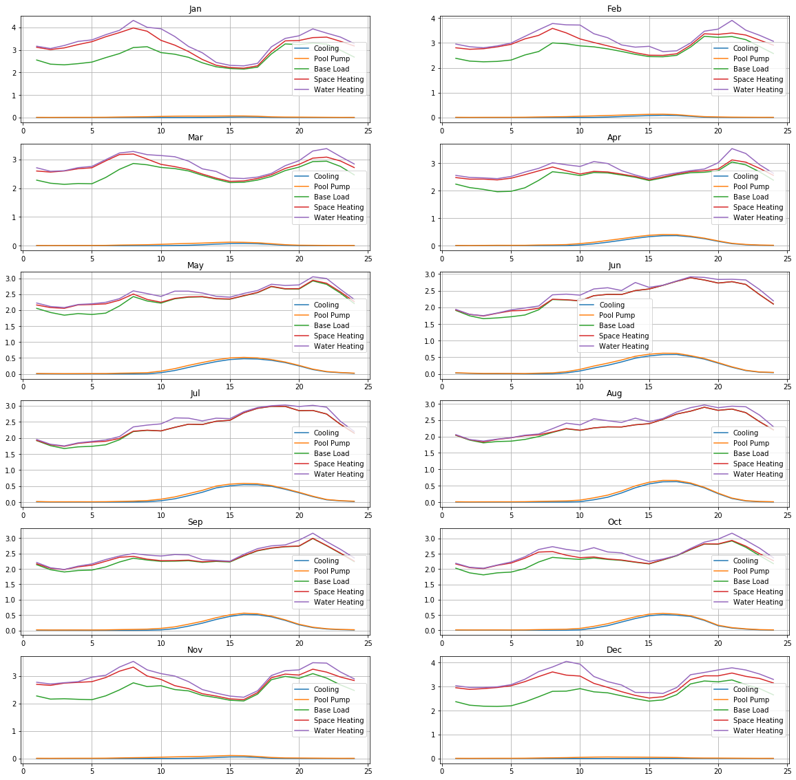Yearly energy costs under flat rate plan: $4594.825008

Yearly energy costs under tiered rate plan: $7815.636784

Yearly energy costs under time of use rate plan: $4187.358219

$/kWh under the cheapest plan: $0.173151

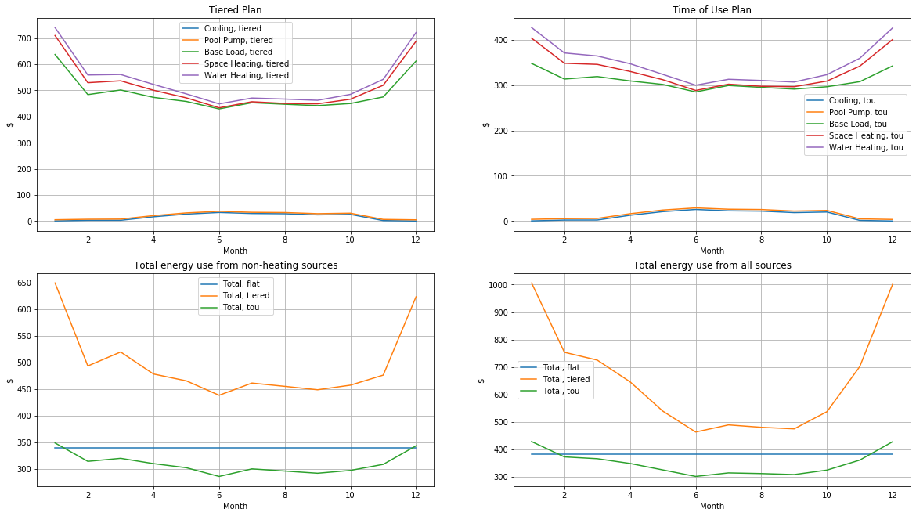

SDG1 (Coastal San Diego, Climate Zone 7)

Lowest Decile

Annual energy use from cooling: 3.646857 kWh

Annual energy use from pool pump: 317.821560 kWh

Annual energy use from base load: 860.002264 kWh

Annual energy use from space heating: 397.598368 kWh

Annual energy use from water heating: 867.358564 kWh

Annual energy use from all sources: 2446.427613 kWh

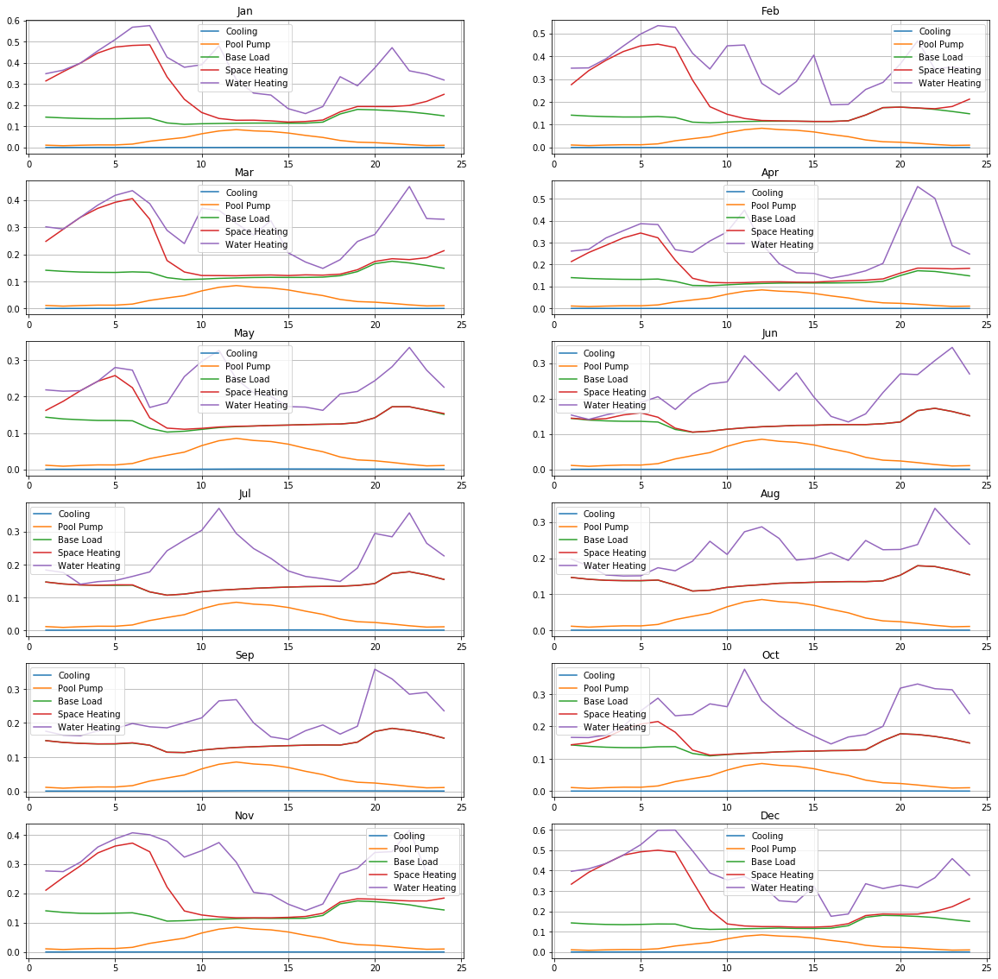Yearly energy costs under flat rate plan: $464.821246

Yearly energy costs under tiered rate plan: $547.412643

Yearly energy costs under time of use rate plan: $422.405761

$/kWh under the cheapest plan: $0.172662

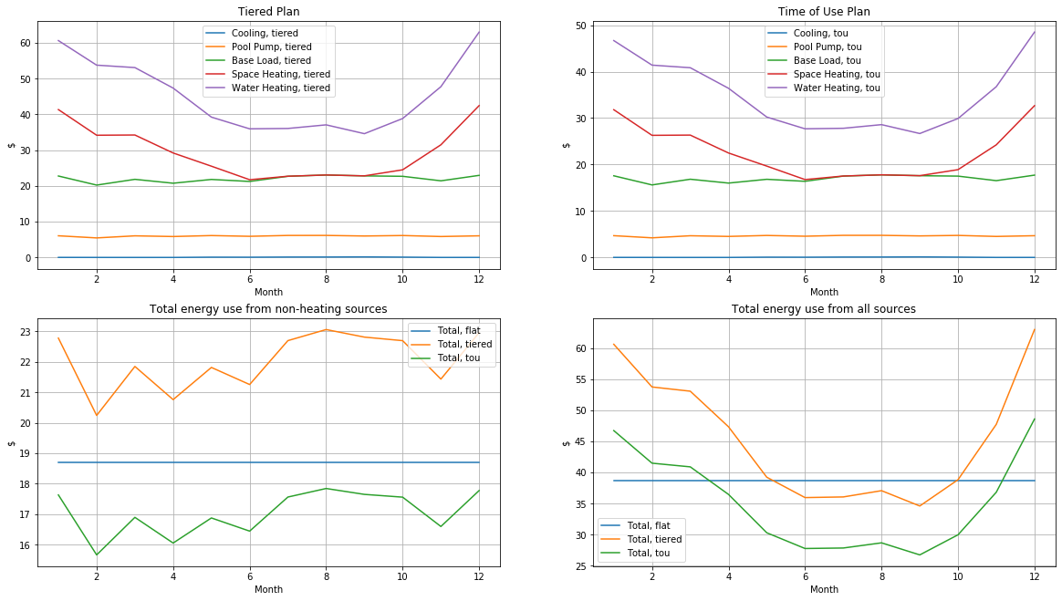

Middle Decile

Annual energy use from cooling: 224.460852 kWh

Annual energy use from pool pump: 317.821560 kWh

Annual energy use from base load: 5060.062531 kWh

Annual energy use from space heating: 397.598368 kWh

Annual energy use from water heating: 867.358564 kWh

Annual energy use from all sources: 6867.301875 kWh

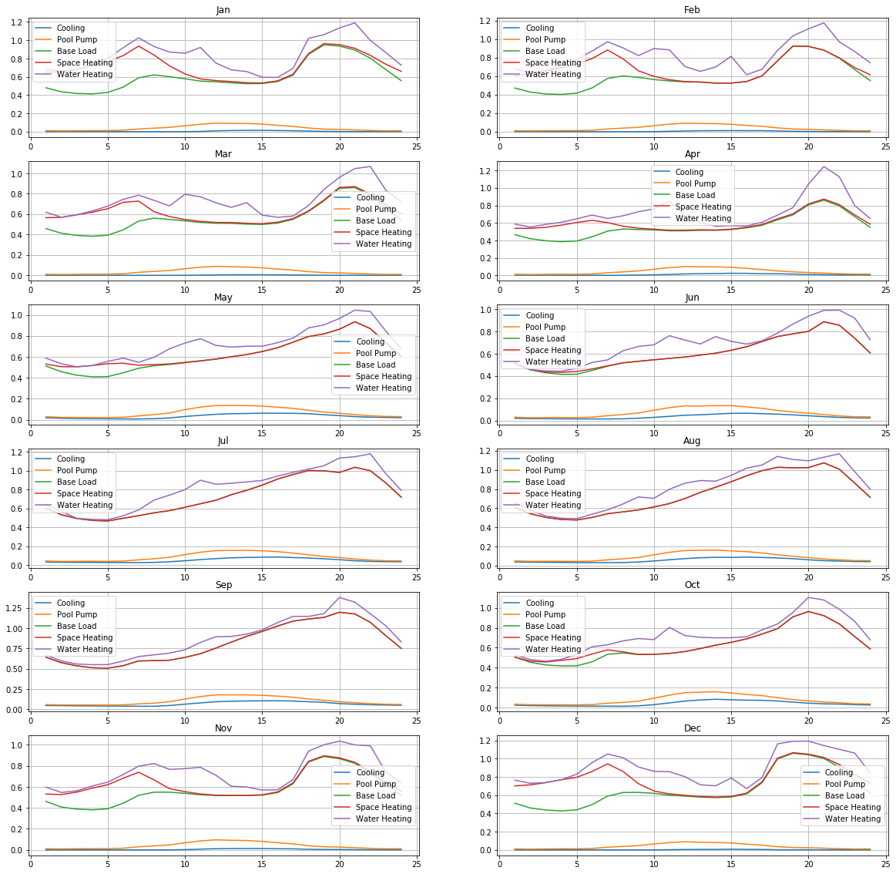

Yearly energy costs under flat rate plan: $1304.787356

Yearly energy costs under tiered rate plan: $1621.481535

Yearly energy costs under time of use rate plan: $1190.165277

$/kWh under the cheapest plan: $0.173309

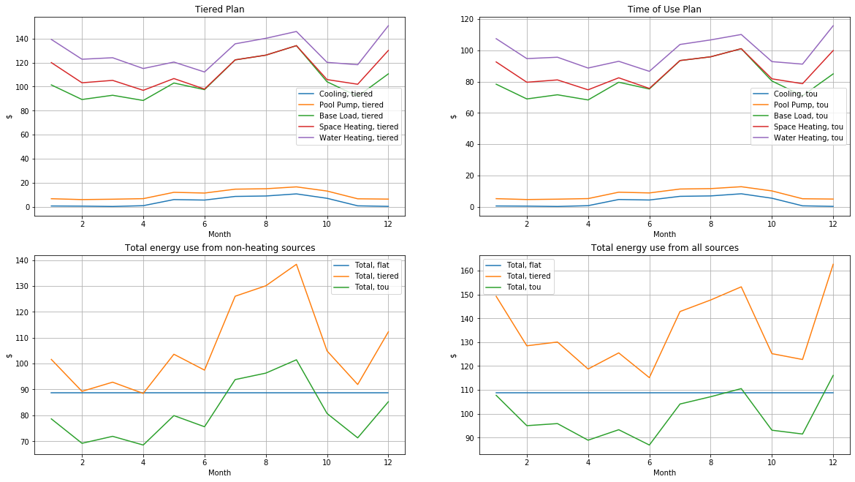

Highest Decile

Annual energy use from cooling: 904.943672 kWh

Annual energy use from pool pump: 317.821560 kWh

Annual energy use from base load: 15473.089976 kWh

Annual energy use from space heating: 397.598368 kWh

Annual energy use from water heating: 867.358564 kWh

Annual energy use from all sources: 17960.812140 kWh

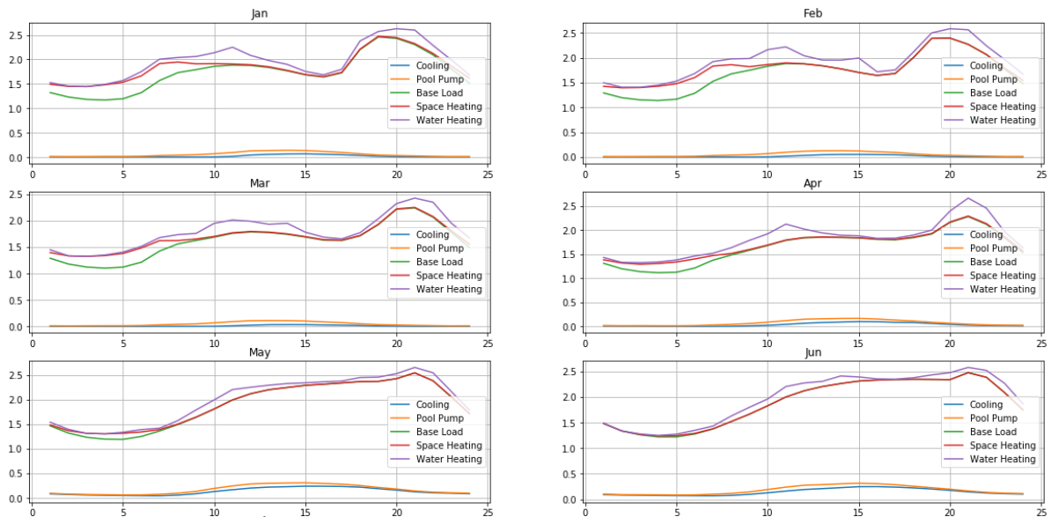

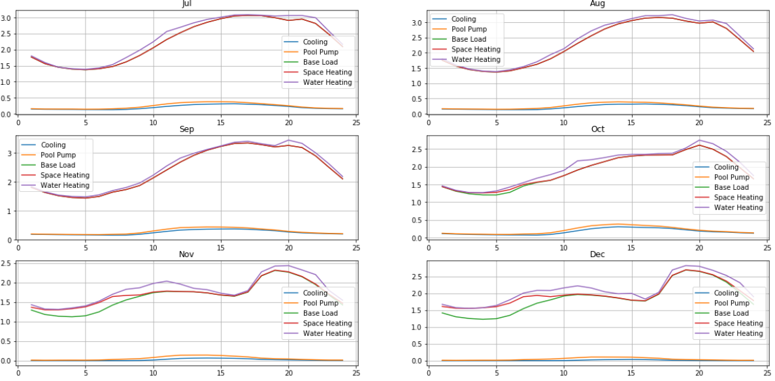

Yearly energy costs under flat rate plan: $3412.554307

Yearly energy costs under tiered rate plan: $4748.027963

Yearly energy costs under time of use rate plan: $3116.061905

$/kWh under the cheapest plan: $0.173492

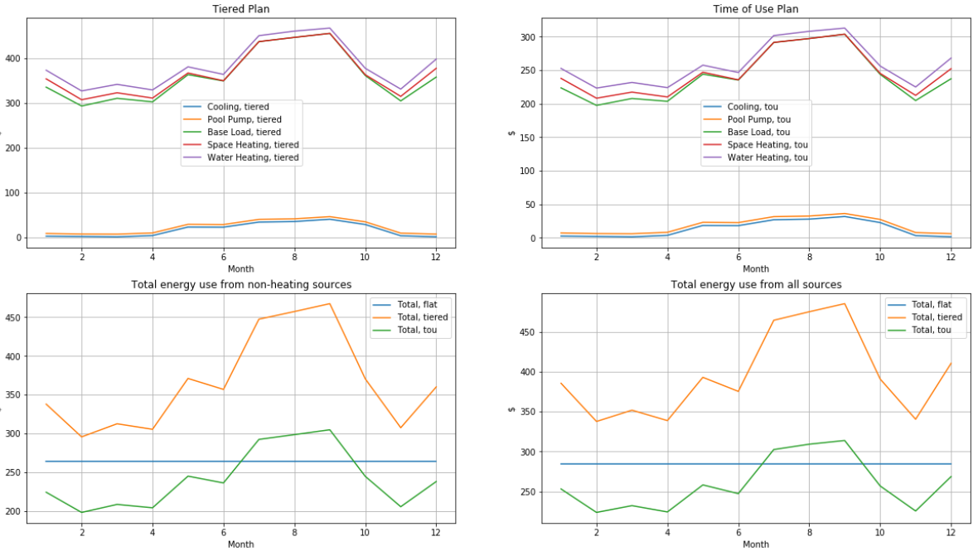

SCEN (Climate Zone 16?)

Lowest Decile

Annual energy use from cooling: 87.863981 kWh

Annual energy use from pool pump: 286.647019 kWh

Annual energy use from base load: 1143.046076 kWh

Annual energy use from space heating: 3521.001584 kWh

Annual energy use from water heating: 1924.664057 kWh

Annual energy use from all sources: 6963.222717 kWh

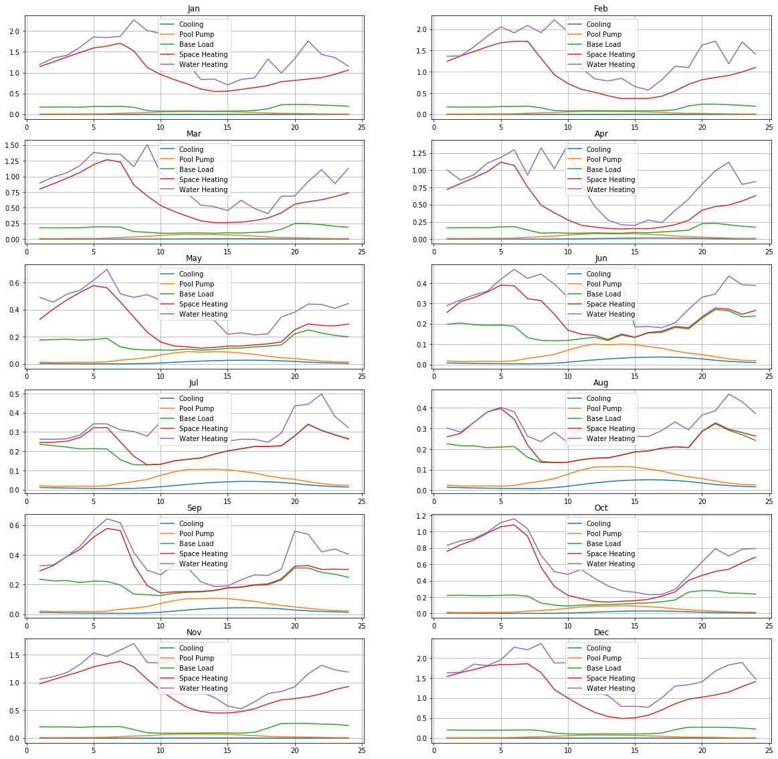

Yearly energy costs under flat rate plan: $1323.012316

Yearly energy costs under tiered rate plan: $1703.129957

Yearly energy costs under time of use rate plan: $1200.996376

$/kWh under the cheapest plan: $0.172477

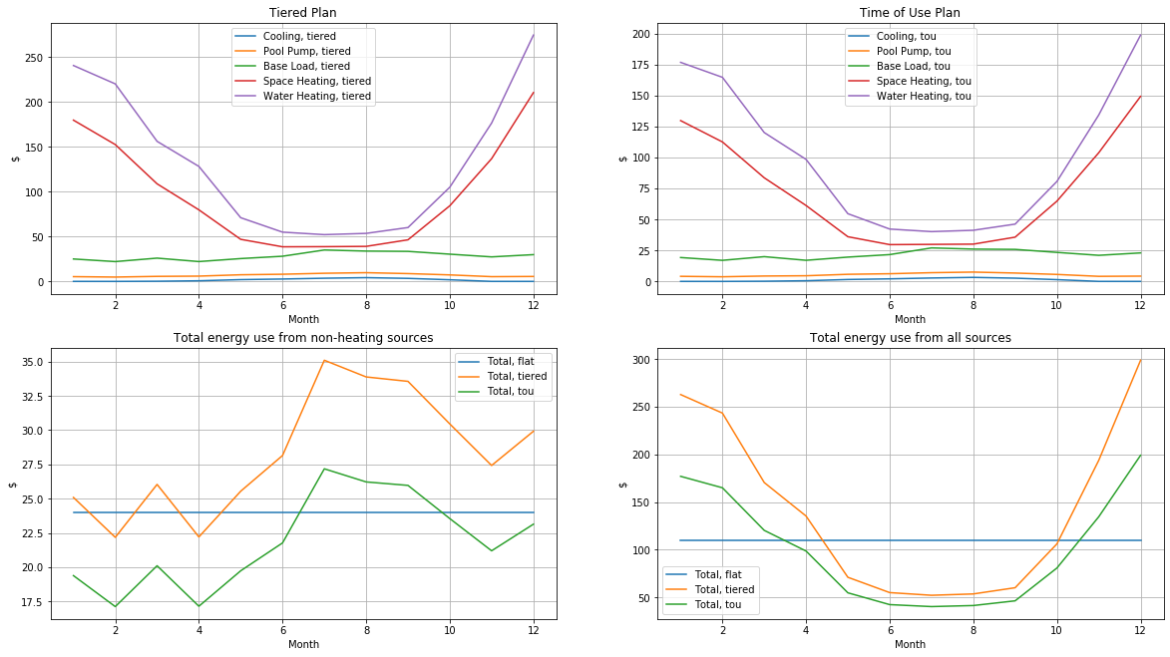

Middle Decile

Annual energy use from cooling: 1525.077384 kWh

Annual energy use from pool pump: 291.336430 kWh

Annual energy use from base load: 6523.177185 kWh

Annual energy use from space heating: 3521.001584 kWh

Annual energy use from water heating: 1924.664057 kWh

Annual energy use from all sources: 13785.256641 kWh

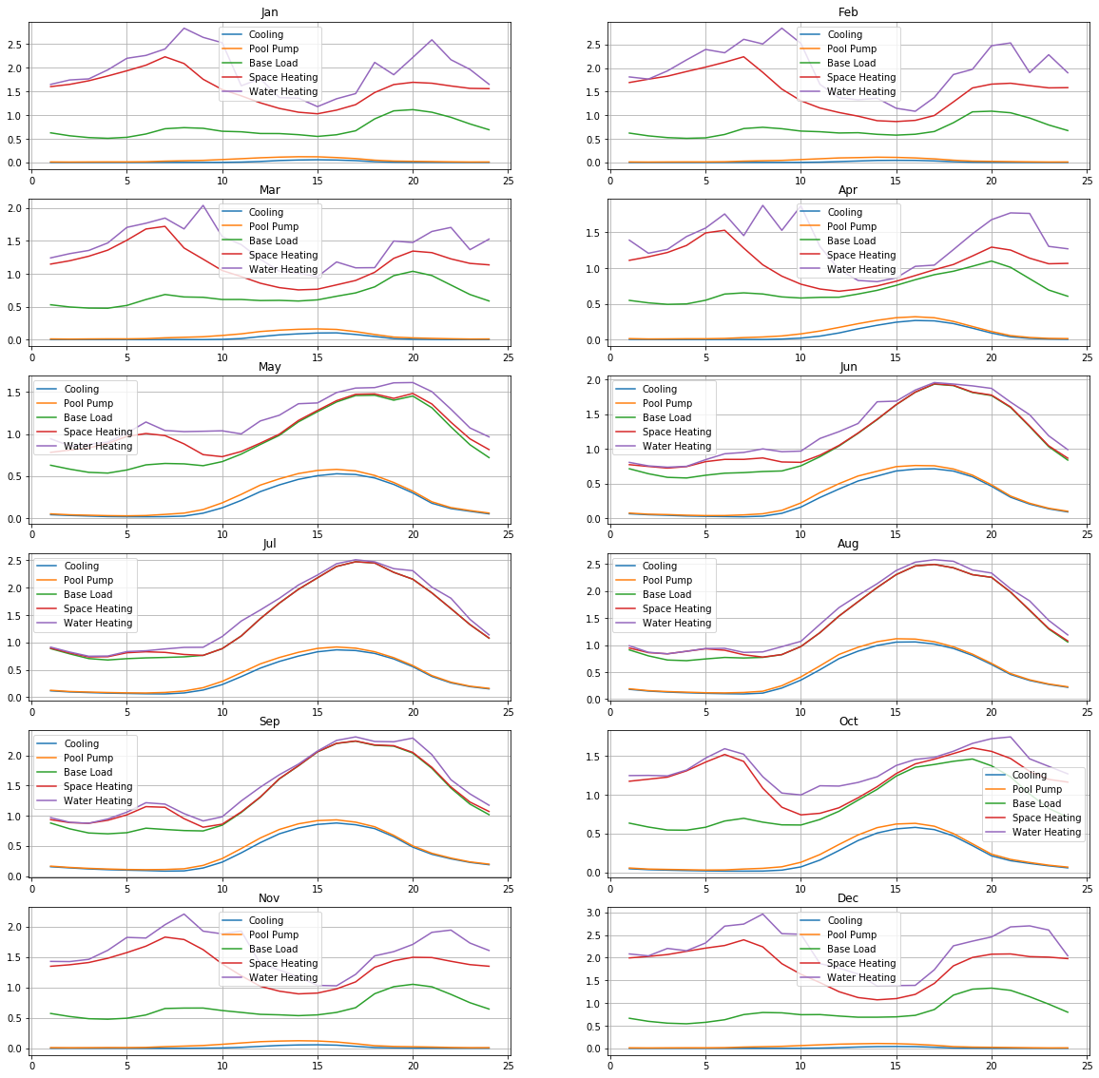

Yearly energy costs under flat rate plan: $2619.198762

Yearly energy costs under tiered rate plan: $3569.508417

Yearly energy costs under time of use rate plan: $2389.518025

$/kWh under the cheapest plan: $0.173339

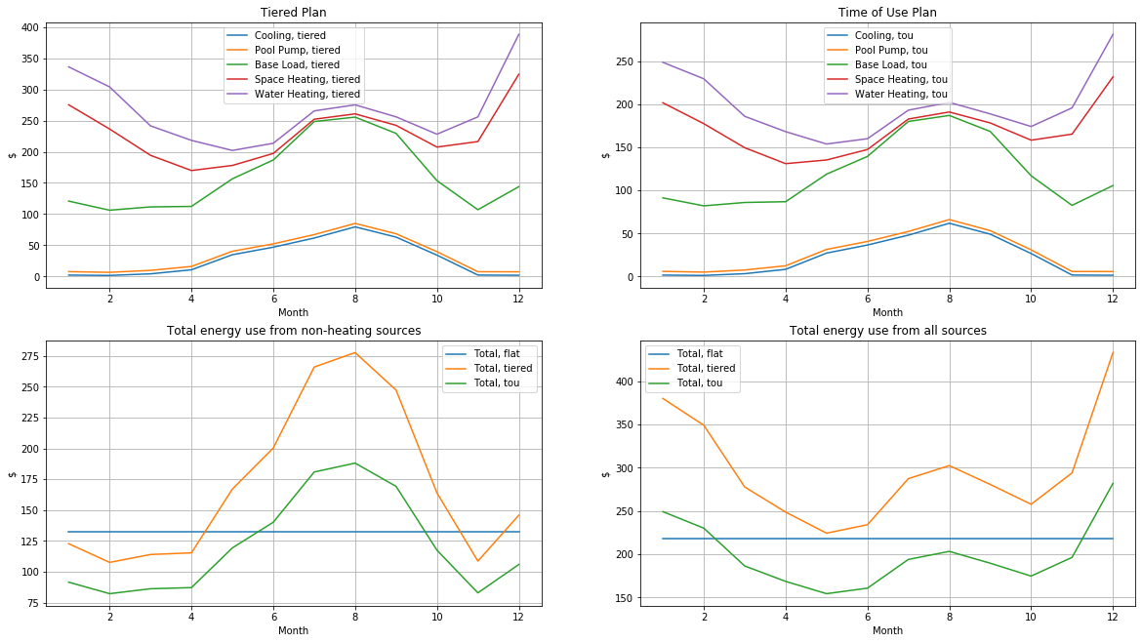

Highest Decile

Annual energy use from cooling: 498.790822 kWh

Annual energy use from pool pump: 291.336430 kWh

Annual energy use from base load: 23378.529434 kWh

Annual energy use from space heating: 3521.001584 kWh

Annual energy use from water heating: 1924.664057 kWh

Annual energy use from all sources: 29614.322326 kWh

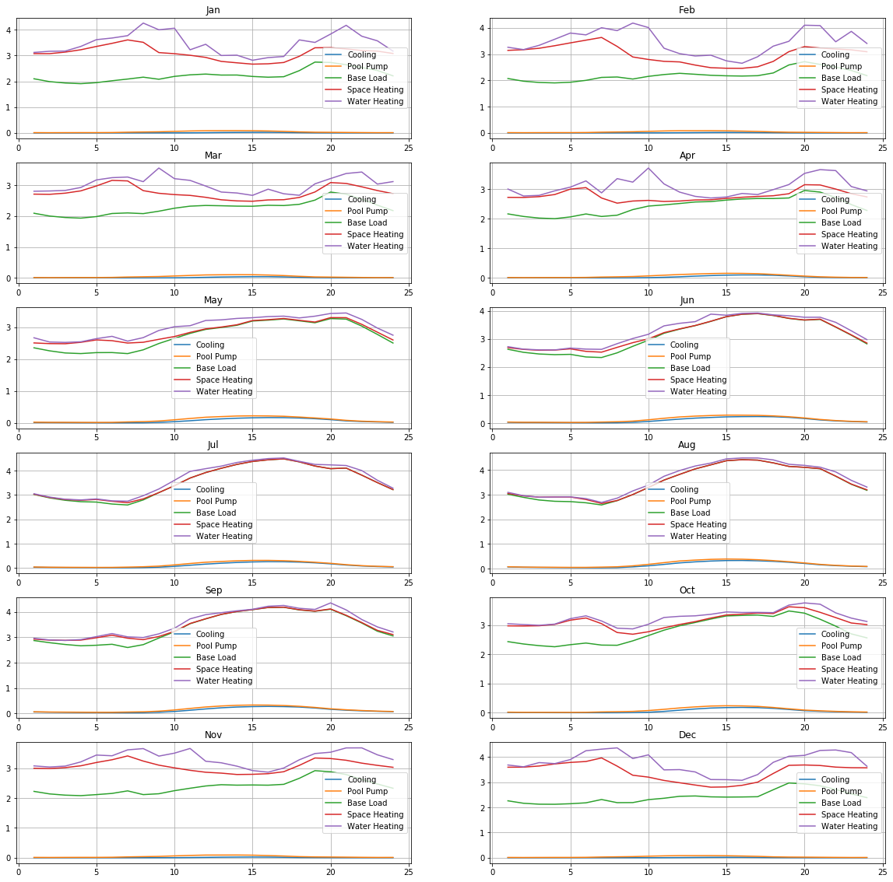

Yearly energy costs under flat rate plan: $5626.721242

Yearly energy costs under tiered rate plan: $11980.600800

Yearly energy costs under time of use rate plan: $5130.839765

$/kWh under the cheapest plan: $0.173255

